App name: Tower Defense (subject to change)

Names: Austin Lui, Jorge Prado, Spencer Reynoso

Eids:

App pages

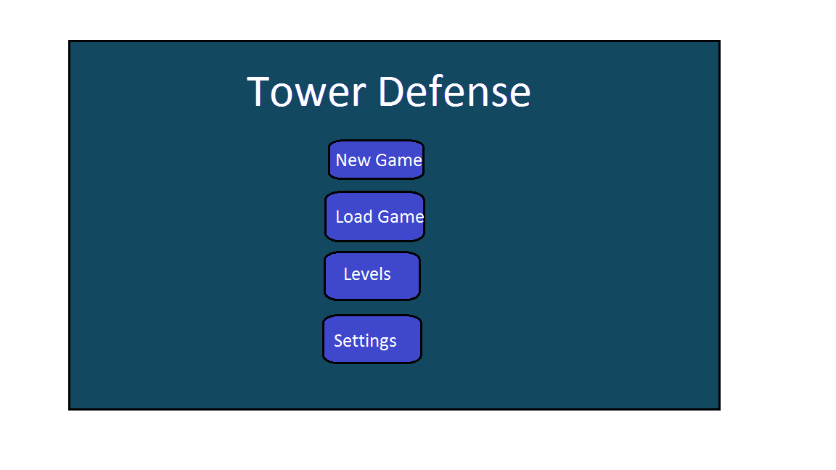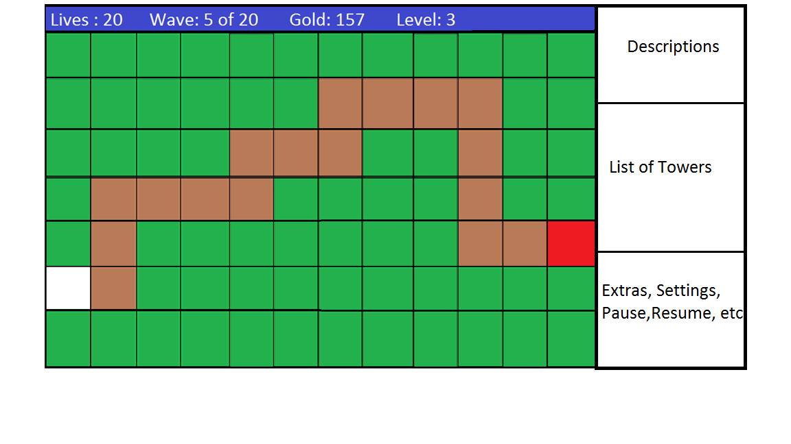

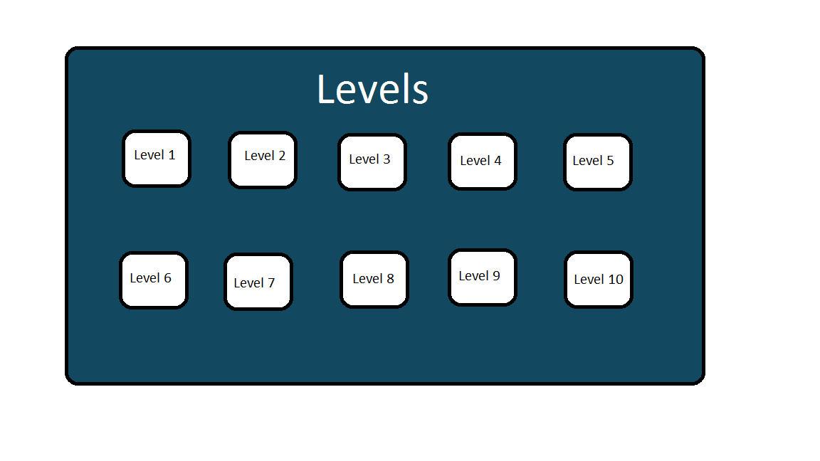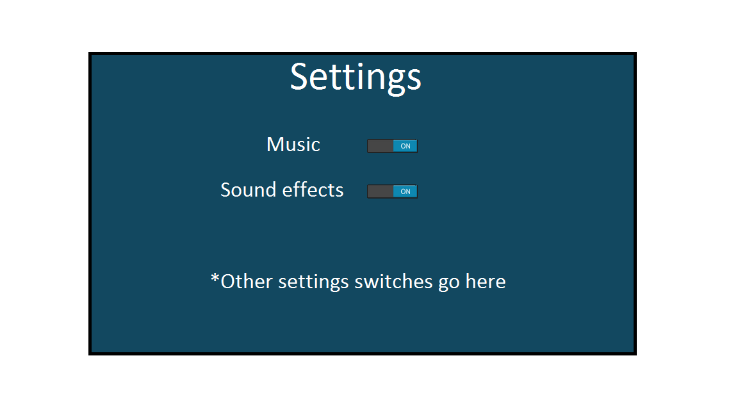

Feature list

1. Ability to save the game and load that game
2. Music and sound effects
3. A screen that will allow the user to jump straight to a level
4. Ability to turn off the music and sounds
5. Fluid animations for the game

Features that may not be implemented

1. Towers and enemies that have elemental characteristics, e.g. fire damage
2. Ability to have multiple save slots
3. Better graphics
4. A rating system to rate how well a player did on a level
5. An endless mode where players play the game until they lose